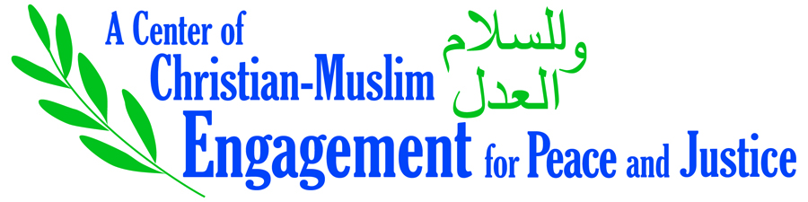
Spring 2019 Re-Envisioning Report
Summary: What We Have Learned

Since the founding of CCME in 2006, we have observed a cultural move from interfaith dialogue to an approach centered on multi-faith and inter-religious engagement, leading us to
- Rethink programming emphases and skills needed in leadership.
- Consider whether the makeup of our leadership team reflects our commitments.

- The past 13 years have led to expanding circles of engagement, which are locally focused and grounded.
- Our constituents: the LSTC community in its diversity, ELCA congregations and institutions (seminaries, churchwide offices), local communities*
- Wider engagement emerging organically (e.g., our relationship with national organizations such as the Shoulder to Shoulder campaign)
- Finding modalities of outside consultation and accountability appropriate to this focus (e.g., ad hoc consultations rather than a standing Advisory Board)

- This re-envisioning year underscores the continuing importance of building and tending relationships.
- Broadening relationships with, for example, alumni, other LSTC centers, comparable programs at other seminaries, Muslim communities besides the ones we know best,* and various areas of Muslims’ concerns and activism*
- A special case: working closely with the American Islamic College*

- CCME’s commitment to maintain a posture of responsiveness with local and national partners is strengthened.
- This has been the source of much of CCME’s best work: hosting conferences and workshops, the highly-regarded chaplaincy seminars, collaboration with the ELCA’s Inter-religious office, Faith over Fear conferences, etc.
- We have some good resources for this work, but it requires staff time and an “ear to the ground.”*

- It has become even more crucial to break down the curricular/extracurricular barrier.
- Continuing need for courses that (a) provide skills and permissions for interreligious engagement; (b) go deep theologically into matters of Christian and Islamic concern, as well as further development of courses that (c) introduce the world of multi-religious activity* to serve the common good, that is, “justice and peace for all creation”
- Helping to shape and support experiences in Contextual Education (Public Church Fellowships, Master of Arts in Ministry internships, Clinical Pastoral Education, MDiv internships, etc.)

- Especially from our consultation partners, we have learned the importance of addressing systemic issues.
- Take Islamophobia seriously as a topic in its own right, alongside teaching about Islam.*
- Work with other partners and initiatives throughout LSTC: Zygon and Pero Centers, Intercultural Development Inventory, anti-racism training, student organizations, etc.
- Foster Intra-Muslim and Intra-Christian engagement.

Asterisk-marked items are especially to be taken into consideration regarding staffing. The emphasis for the proposed new staff position would be to engage and introduce students to the world of multi-religious work within the wider Chicago community and in their future vocations. Ideally, a new colleague would be a Muslim/ah in a position of Associate Director or Co-Director.
From the ELCA’s proposed policy statement, A DECLARATION OF OUR INTER-RELIGIOUS COMMITMENT, to be considered by voting members at the August 2019 churchwide assembly.

